3rd ANNOUNCEMENT
PAWEES 2013
The 12th Conference of
International Society of Paddy and Water Environment Engineering

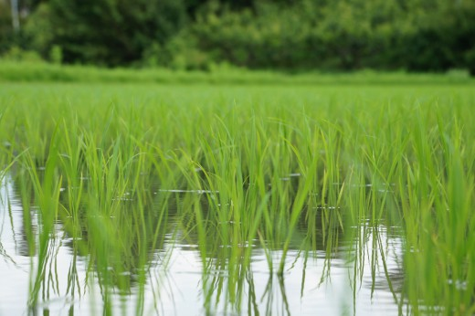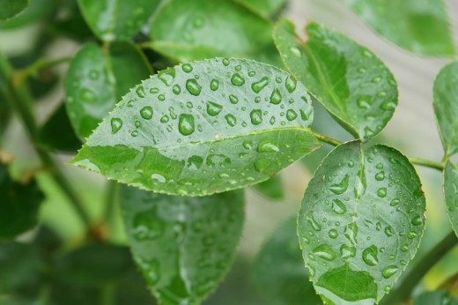

30 October – 1 November 2013
Cheongju, South Korea

The 12th PAWEES Conference theme is “Agricultural water and rural environment for the future”.

THEMES

Theme 1: Climate Change and Water Resources

Theme 2: Sustainable Soil and Water Management

Theme 3: Rural Planning and Environment
Theme 4: Agricultural Nutrient Management and Environmental Quality
Theme 5: Multifunctional Role of Agricultural Water in Terms of Social and
Economic Effect

PAPER
The authors of accepted abstract are recommended to submit full paper with designated form. The submitted abstract and paper will be published in the proceedings. The conference proceedings can be collected at the registration desk.

Language
Paper should be submitted in English.

Instruction for authors
Authors are requested to submit the full paper through in Microsoft Word version. The e-mail address for paper submission: mwjang@gnu.ac.kr
Full paper should be written by the following text formatting.

Text Formatting
Please refer to formatting instructions at http://pawees.net/?page_id=206.
Manuscripts should be submitted in Word format.
- Use a normal, plain font (e.g., 11-point Times Roman) for text.
- Use italics for emphasis.
- Use the automatic page numbering function to number the pages.
- Do not use field functions.
- Use tab stops or other commands for indents, not the space bar.
- Use the table function, not spreadsheets, to make tables.
- Use the Equation Editor or MathType for equations.

Presentations
Papers
Time allotments for presentations shall be determined by the session program and chairperson.

Posters
Poster boards are 8' high with a surface of 4' x 6' and are placed in rows in a large hall. Presenters are asked to be at their assigned poster board during the entire length of the poster session.

Important Date
Full Paper Submission for Proceeding: September 30, 2013
Deadline for Registration: September 30, 2013

Send your inquiry regarding the submission to:
Dr. Min Won Jang, Gyeongsang National University, Korea (mwjang@gnu.ac.kr, +82-55-751-5432)

REGISTRATION FEES
The registration fees are USD 200 (KRW 220,000; JPY 20,000) for adults and USD 100 (KWR 110,000; JPY 10,000) for students and accompanying persons. The registered delegates and participants shall be provided during the Conference with a conference kit, programs and proceedings, official snacks, lunches and reception dinner, attendance in opening program, and field trip. Only payments and issue of receipts will be done on site.

VENUE
Ramada Plaza HOTEL
Address: 500-3 Yulrang-dong, Sangdang-gu, Cheongju, Chungbuk, Korea
Tel: +82-43-290-1000
Fax: +82-43-290-1010
Email: webmaster@ramadakorea.co.kr
Website: https://www.ramadakorea.co.kr/
Check-in Time: 03:00 PM
Check-out Time: 12:00 PM
Fee: 137,000 won/day (One person, Including breakfast), 154,000 won/day (Two persons, Including breakfast)

Accommodations

REEHO TOURIST HOTEL
Address: 35-7 Biha-dong, Heungdeok-gu, Cheongju, Chungbuk, Korea
Tel: +82-43-233-8800
Website: https://www.hotelreeho.co.kr/
Check-in Time: 02:00 PM
Check-out Time: 12:00 PM
Fee: 80,000 won/day (Including breakfast)

Hotel gallery
Address: Bongmyeong-dong, Heungdeok-Gu, Cheongju, Korea
Tel: +82-43-267-1121
Fax: +82-43-263-9532
Email: info@newgalleryhotel.com
Website: https://www.newgalleryhotel.com/
Check-in Time: 02:00 PM
Check-out Time: 12:00 PM
Fee: 66,000 won/day (Including breakfast)

At the Cheongju Cross-county Bus Terminal, you may take a taxi to the Ramada Plaza and Hotel Gallery. It takes about 25 and 15 minutes respectively, and the fare is about 10,000 won and 7,000 won if not in traffic. Reeho Hotel is also located 5 minute walk distance.

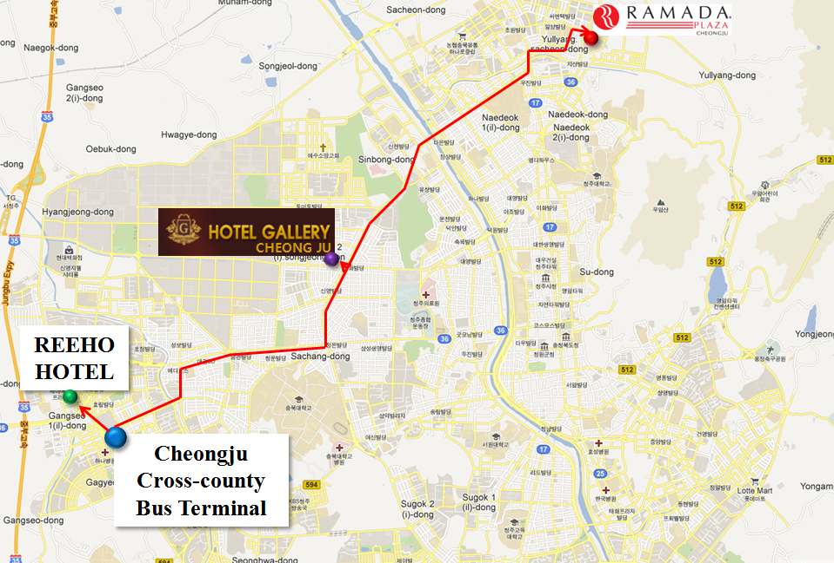

Incheon International Airport (ICN) to Ramada Plaza Cheongju, Reeho Tourist Hotel and Hotel Gallery
Located about 130km northwest of Cheongju, Incheon International Airport wins the Airport Service Quality (ASQ) Award for the eighth year in a row to be the first in the industry, and at the same time reaching a remarkable achievement of operating the world’s second largest amount of air cargo and the world’s ninth largest number of passengers in 2012 based on its wide aviation network across 173 cities in 53 countries.
Website: http://www.airport.or.kr
Tel.: +82-1577-2600
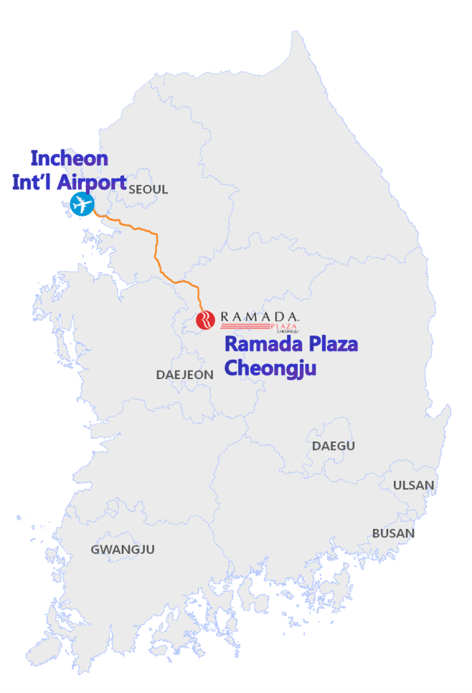
By Airport Limousine
You can get information about Limousines Buses, and ticketing at the following ticket booths : Exit 4 and 9 (indoors) & Exit 4, 6, 7, 8, 11, 13, and 9C (outdoors). The bus stop for Cheongju is at 9D on the 1st Floor. The fares are 18,700 won and 20,600 won (after 23:00) to Cheongju Cross-county Bus Terminal. The bus runs every 20~60 minutes from 06:30 to 23:10, and it takes about 120~150 minutes. Do not confuse Cheongju (청주, 淸州) with Chungju (충주, 忠州) and Jeonju (전주, 全州).

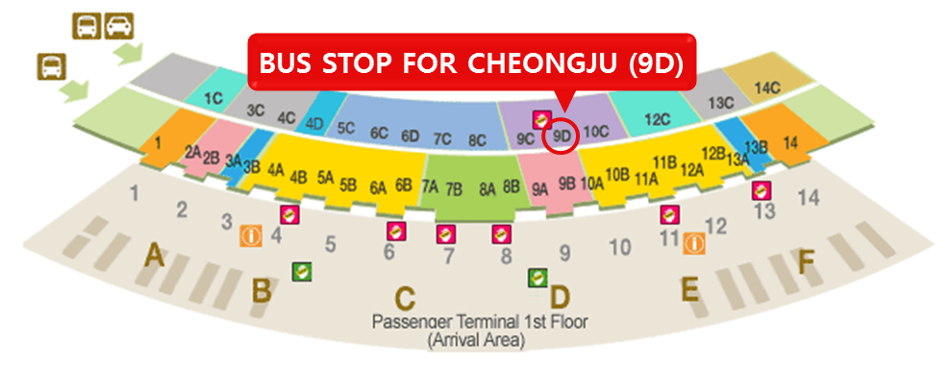

At the Cheongju Cross-county Bus Terminal, you may take a taxi to the Ramada Plaza Cheongju. It takes about 25 minutes, and the fare is about 10,000 won if not in traffic.

By Airport Railroad Express (AREX) - KTX
You can take the Airport Railroad Express (on B1 floor) for Seoul KTX Station. It takes 43 minutes for Express train and 53 minutes for Commuter train between Incheon International Airport and Seoul KTX Station. The fares are 8,000 won and 3,950 won, respectively.
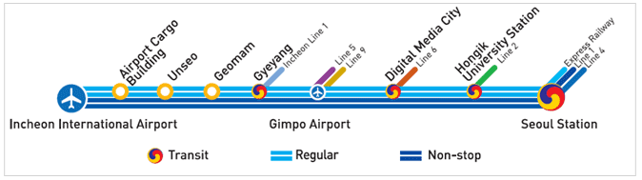
At Seoul Station, KTX (Korean Train Express) comfortably takes you to Osong Station about 22 km west of the Ramada Plaza Cheongju. It runs almost every hour, and the fare is 17,200 won (but 18,500 won from Friday to Sunday). It takes about 45-55 minutes.
You can get a taxi to the hotel at the Osong Station (travel time: approx. 35 minutes, fare: 20,000 won).
*Incheon Airport Rental Car Service (KT Kumho/AVIS)
You may want to rent a car at the ICN. Car rental service is available at near Exit 3 on the terminal 1F.

Gimpo International Airport (GMP) to Ramada Plaza Cheongju
If you arrive at the Gimpo International Airport, you can get a bus for Cheongju at the stop 1 on the 2nd floor in the international terminal. The fare is 11,500 won (12,800 Won for 22:40) to the Cheongju Cross-county Bus Terminal. The bus runs every one hour from 08:00 to 22:40, and it takes about 120 minutes.

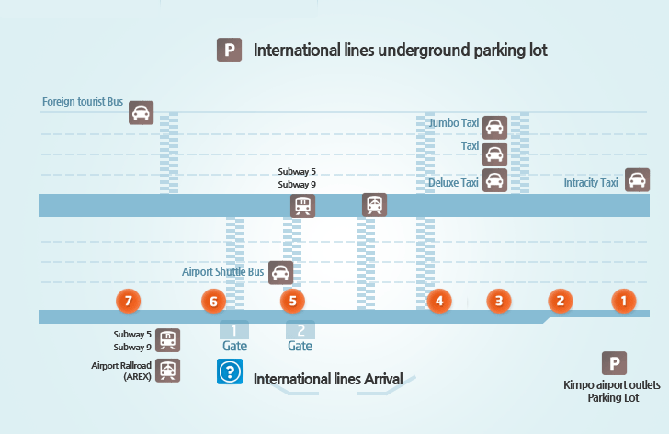

Application for VISA
Any foreign visitors wishing to enter the Republic of Korea must have a valid passport and obtain a Korean visa before coming. However, people of 99 countries who want to visit Korea temporarily are permitted to enter without a visa according to visa-exemption agreements (Table 1), or in accordance with principles reciprocity or national interest (Table 2). You will find more information at Ministry of Foreign Affairs and Trade (http://www.mofat.go.kr) and Immigration Bureau (http://www.immigration.go.kr).

Table 1. Countries under Visa Exemption Agreements
Country/Period(days)
Europe | Austria / 90  Belgium / 90  Bulgaria / 90  Czech Republic / 90  Denmark / 90  Estonia / 90  Finland / 90  France / 90  Greece / 90 | Germany / 90  Hungary / 90  Iceland / 90  Ireland / 90  Italy / 60  Liechtenstein / 90  Luxembourg / 90  Malta / 90  Netherlands / 90 | Norway / 90  Portugal / 60  Poland / 90  Romania / 90  Spain / 90  Slovak Republic / 90  Sweden / 90  Switzerland / 90  United Kingdom / 90
Asia and Oceania | Bangladesh / 90  Israel / 90  Malaysia / 90 | New Zealand / 90  Pakistan / 90  Singapore / 90 | Thailand / 90  Turkey / 90
Americas | Antigua and Barbuda / 90  Bahamas / 90  Barbados / 90  Brazil / 90  Colombia / 90  Costa Rica / 90  Common wealth of  Dominica / 90 | Dominican Republic / 90  El Salvador / 90  Grenada / 90  Haiti / 90  Jamaica / 90  Mexico / 90  Nicaragua / 90 | Panama / 90  Peru / 90  St. Lucia / 90  St. Kitts and Nevis / 90  St. Vincent & the  Grenadines / 90  Surinam / 90  Trinidad and Tobago / 90
Africa | Lesotho / 60  Liberia / 90 | Morocco / 90 | Tunisia / 30

Table 2. Countries or Regions under principles of reciprocity and national interest
Country/Period(days)
Asia | Brunei / 30  Hong Kong / 90  Japan / 90  Kuwait / 30 | Macao / 30  Oman / 30  Qatar / 30  Saudi Arabia / 30 | Taiwan / 30  United Arab emirates / 30  Yemen / 30
North America | Canada / 180 | United States / 30
South America | Argentina / 90  Chile / 90  Guatemala / 30 | Honduras / 30  Paraguay / 30 | Uruguay / 30  Venezuela / 30
Europe | Albania / 30  Croatia / 90  Cyprus / 30 | Latvia / 90  Lithuania / 90  Monaco / 30 | Slovenia / 90  Vatican / 30
Oceania | Australia / 90  Fiji / 30  Guam / 30 | Kiribati / 30  Marshall Islands/ 30  Palau / 30 | Nauru / 30  New Caledonia / 30
Africa | Republic of South Africa / 30 | Swaziland / 30

Tourist & Business Visas
Visitors from countries not under Visa Exemption Agreements must apply for a visa extension if planning to stay for more than 30 days. Depending on the situation of the consulate, the visa extension will be issued 1 to 3 days from the day of application. Applicants require a completed application form, a recent passport-size colorful photo and application fee. Visitors do not require the outbound flight ticket. Visa extensions are usually for 90 days. All visas including long-term visas are for a single visit. Therefore anyone who wishes to leave the country and re-enter later on during the allowed period of stay should obtain the Re-entry Permit from the Ministry of Justice prior to departure. For business visas, the intention of activities must be clearly stated on the visa application form.

Application for Visas
Visa application should be made at Korean Embassies or consulates abroad.
It is required for the visa applicants to submit passport, application forms, a recent passport-style color photograph, and such other documents as determined by the status of stay.
Visa fees are as follows:
A. Single entry visa for a stay of no more than 90 days: USD30
B. Single entry visa for a stay of more than 90 days: USD50
C. Multiple entry visa: USD80
D. Prolongation of Re-entry Permit : USD20
For Citizens of United States of America, multiple entry visa fee is USD45 on the basis of reciprocity since the mutual agreement in 1994.

Visa Extension
Extensions for tourist visas are possible in special cases such as accidents, health problems, flight cancellation, etc. Applications for visa extensions can be made at a local immigration office at least one day before the day of expiration.

ORGANIZING COMMITTEE

1.Advisory Committee

Chairperson
Dr. Jin Soo Kim, President of KSAE, Chungbuk National University, Korea (+82-43-261-2573, jskim@cbnu.ac.kr)

Co-Chairperson
Mr. Wei-Fuu Yang, President of PAWEES, Taiwan
CEO of KRC (Korea Rural Community Corporation) http://eng.ekr.or.kr/Kenpub/index.krc

Advisor
Dr. Yohei Sato, Honorary President of PAWEES, Japan
Dr. Sho Shiozawa, President of JSIDRE, Japan
Dr. Tai Cheol Kim, Former President of PAWEES, Korea
Mr. Yeon-Tae Min, Director of Ministry of Agriculture, Food and Rural Affairs, Korea

2.Scientific Committee

Chairperson
Dr. SeongJoon Kim, Konkuk University, Korea(kimsj@konkuk.ac.kr, +82-2-450-3749)

Co-Chairperson
Dr. Masaru Mizoguchi, Editor-in-chief, PWE (University of Tokyo, Japan)
Dr. Yoshiyuki Shinogi, Chief Managing Editor, PWE (Kyusyu University, Japan)
Dr. Joongdae Choi, Editing Board, PWE (Kangwon National University, Korea, jdchoi@kangwon.ac.kr)
Dr. Chen-Wuing Liu, Editor, PWE (National Taiwan University, Taiwan)

Member
Dr. Yutaka Matsuno, Secretary General of PAWEES (Kinki University, Japan)
Dr. Takao MASUMOTO, National Institute for Rural Engineering, Japan
Dr. Fi-John Chang, National Taiwan University, Taiwan
Dr. Ke-Sheng Cheng, National Taiwan University, Taiwan
Dr. Moon Seong Kang, Seoul National University, Korea(mskang@snu.ac.kr, +82-2-880-4582)
Dr. Song Bae Kim, Seoul National University, Korea(songbkim@snu.ac.kr, +82-2-880-4587)
Dr. Se Woong Chung, Chungbuk National University, Korea (schung@chungbuk.ac.kr, +82-43-261-3370)
Dr. Jae Kyoung Noh, Chungnam National University, Korea(jknoh@cnu.ac.kr)
Dr. Seung Ki Park, Kongju National University, Korea(skpark@kongju.ac.kr)
Dr. Jin Kyu Choi, Chonnam National University, Korea(choijk@chonbuk.ac.kr)
Dr. Sang Min Kim, Gyeongsang National University, Korea(smkim@gnu.ac.kr, +82-55-751-2431)
Dr. Sung Gu Hong, Hankyong National University, Korea(bb9@hknu.ac.kr, +82-10-7474-4586)
Dr. Jae Gwon Son, Chonbuk National University, Korea(sjg@chonbuk.ac.kr, +82-63-270-2523)
Dr. Kwang Sik Yoon, Chonnam National University, Korea(ksyoon@chonnam.ac.kr)
Dr. Ji Hong Jeon, Andong National University, Korea(jhjeon@andong.ac.kr, +82-54-820-5093)
Dr. Dong Seok Shin, National Institute of Environmental Research, Korea(sds8488@korea.kr, +82-43-730-5631)
Dr. Hyeon Jun Kim, Korea Institute of Construction Research, Korea(hjkim@kict.re.kr, +82-31-910-0266)
Dr. Dae Sik Kim, Chungnam National University, Korea(drkds19@cnu.ac.kr, +82-42-821-5795)
Dr. Ki Sung Kim, Kangwon National University, Korea(kskim@kangwon.ac.kr, +82-33-250-6466)
Dr. Han Cheol Hwang, Hankyong National University, Korea(hwang@hknu.ac.kr, +82-31-670-5133)
Dr. Young Hwan Son, Seoul National University, Korea (syh86@snu.ac.kr, +82-10-9948-9586)
Dr. Yong Seong Kim, Kangwon National University, Korea(yskim2@kangwon.ac.kr)

Member and Secretary
Dr. Kyoung Jae Lim, Kangwon National University, Korea(kjlim@kangwon.ac.kr, +82-33-250-6468)
Dr. Min Won Jang, Gyeongsang National University, Korea(mwjang@gnu.ac.kr, +82-55-751-5432)

3.Local Organizing Committee
Chungbuk National University

Chairperson
Dr. Seung Jin Maeng, Chungbuk National University (maeng@cbnu.ac.kr)

Co-Chairperson
Dr. Jin Yong Choi, Seoul National University, Korea(iamchoi@snu.ac.kr, +82-10-7474-4586)
Dr. Kyung Sook Choi, Kyungpook National University, Korea(ks.choi@knu.ac.kr, +82-53-950-5731)

Member
Mr. Jung Beom Lee, Chungbuk National University(goaehd3@hanmail.net)
Mr. Sihong Li, Chungbuk National University (cnhonghong@hotmail.com)
Mr. Jae Yong Lee, Chungbuk National University (dowodyd@naver.com)
Mr. Ji Hoon Shim, Chungbuk National University (jhshim@cbnu.com)

Secretary
Miss. Ji Hye Jeong, Chungbuk National University (jeongjihye@chungbuk.ac.kr)

Contact
PAWEES2013 Local Organizing Committee
Contact Person: Dr. Seung Jin Maeng
Tel: +82-43-261-2576
Fax: +82-43-271-5922
Email: maeng@cbnu.ac.kr

PROGRAMME
The PAWEES2013 Conference program details are currently being prepared as follows:

Time | Key Contents
29 October, Tuesday | - Arrival
30 October, Wednesday | - Conference I  - Opening ceremony  - Conference II  - Reception
31 October, Thursday | - Conference III  - Award Ceremony  - Agenda Meeting (Student Session III)  - Dinner
1 November, Friday | - Technical Trip
2 Saturday, November | - Departure

Date | Time | Contents
30 October, Wednesday | 8:20~9:20 | Registration
 | 9:20~12:30 | Conference I
 | 12:30~13:30 | Lunch
 | 13:30~14:20 | Opening Ceremony & Keynote Speech
 | 14:20~14:30 | Coffee Break
 | 14:30~18:00 | Conference II
 | 18:30~20:30 | Reception
31 October, Thursday | 8:30~9:00 | Registration
 | 9:00~11:00 | Conference III
 | 11:00~12:30 | Award Ceremony
 | 12:30~13:30 | Lunch
 | 13:30~16:00 | Agenda Meeting & Wrap up, Student Session III
 | 18:00~19:30 | Dinner
1 November,  Friday | 9:00~16:00 | Field Trip  Four-river Restoration Project Sites

ORGANIZERS
International Society of Paddy and Water Environment Engineering (PAWEES)
Korean Society of Agricultural Engineers (KSAE)
Chungbuk National University (CBNU)
Ministry of Agriculture, Food and Rural Affairs (MAFRA)
Korea Rural Community Corporation (KRC)
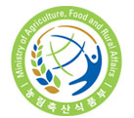

Registration Form

All participants are asked to complete and submit the registration form to master@ksae.re.kr or by fax to +82-2-565-6821 until 30 September.
Delegate Information
Title | Mr. ( ) Mrs. ( ) Ms. ( ) Dr. ( ) Prof. ( ) etc. ( )
First Name |  |  |  |  | Last Name
Country |  |  |  |  | Gender |  | Male ( ) Female ( )
Position
Organization
Address
 | City |  |  |  |  | Zip Code
Email | @ |  |  |  |  | Fax
Phone | +Country Code-Area Code-Phone No |  |  |  |  | Mobile Phone
Date of Birth | Month/Day/Year
Flight Information
Arrival | Airline
 | Flight No.
 | Airport Name |  |  | Inchoen Airport / Kimpo Airport / Cheongju Airport
 | Date |  |  |  |  | Time
Departure | Airline
 | Flight No.
 | Airport Name |  |  | Inchoen Airport / Kimpo Airport / Cheongju Airport
 | Date |  |  |  |  | Time
Type of Participation |  | Oral Presentation ( ) Poster ( ) Representative ( ) Observer ( )
Check Hotel Name | ( ) Ramada Plaza Hotel  ( ) Reeho Tourist Hotel  ( ) Hotel Gallery  Other:
Stay:  ( ) Days and ( ) Nights |  |  |  |  |  | Date of check-in |  | Month/Day/Year
 |  |  |  |  |  | Date of check-out |  | Month/Day/Year
Meals: | Vegetarian ( ) Non-Vegetarian ( )

Time Schedule for Paper/Poster Presentation
30 October, Wednesday | Room A |  | Room B |  |  | Room C |  | Poster  (Lobby)  Sticking  8:20-  9:20  Presentation  17:20-  18:20  (25 posters)
 | Theme 1 | Theme 2 | Theme 3 | Theme 4 |  | Student Session I | Reception  18:30 – 20:30
 | Session 1-1  9:20-11:00  (5 presentations) | Session 2-1  14:30-16:10  (5 presentations) | Session 3-1  9:20-11:00  (5 presentations) | Session 4-1  14:30-16:10  (5 presentations) |  | Session 6-1  9:20-11:00  (6 presentations)
 | Break (10 mins) | Break (10 mins) | Break (10 mins) | Break (10 mins) |  | Break (10 mins)
 | Session 1-2  11:10-12:30  (4 presentations) | Session 2-2  16:20-18:00  (5 presentations) | Session 3-2  11:10-12:30  (4 presentations) | Virtual Water Special Session  16:20-18:00 |  | Session 6-2  11:10-12:30  (5 presentations)
31 October, Thursday | Room A |  | Room B |  |  | Room C |  | For each presentation  General;  20 mins  Students;  15 mins  Including Q&A
 | Theme 5 |  | Theme 4 |  |  | Student Session II | Student Session III
 | Session 5  9:00-11:00  (6 presentations) |  | Session 4-2  9:00-11:00  (6 presentations) |  |  | Session 6-3  9:00-10:45  (7 presentations) | Session 6-4  14:30-15:45  (5 presentations)

